# Chapter 15: Local data with web storage

In this chapter we will be looking at two web storage mechanisms, localStorage and sessionStorage.

## Lesson 1: Introducing web storage

### Understanding cookies

Cookies provide a way for us to store **non-sensitive** information on the browser, so we do not have to make a trip to the server all the time.

The code below shows us how to Set and Get A Cookie:

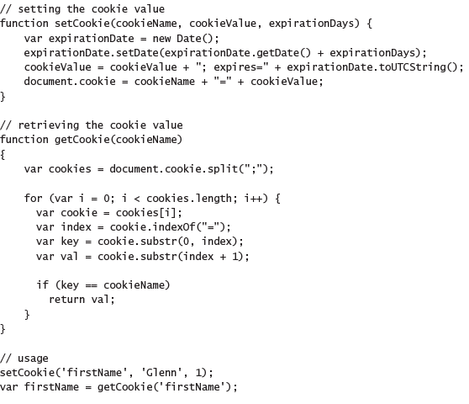

JSFiddle: https://jsfiddle.net/kmk6z95z/

**NOTE**: you must upload your file to a web server to set cookies on Google chrome (http://stackoverflow.com/questions/8105135/cannot-set-cookies-in-javascript)

### Using the jQuery cookie plug-in

The plugin can be found here: *https://github.com/carhartl/jquery-cookie*.

E.g.

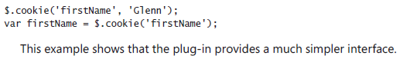

### Working with cookie limitations

1. Capacity limitations: cookies are limited to about 4kb of data. Additionally, only 30 cookies can be created per site (actual number of cookies varies by browser; the average is between 30 and 50)

2. Overhead: **Every** cookie is sent with each HTTP request/response made, regardless of whether the values are needed.

### Alternatives to cookies prior to HTML5

- Flash player  
- User Data (IE only)  
- Google Gears (support discontinued)  
- Java Applet

### Looking beyond plug-ins

The following are issues related to plug-in use:

* Plug-in & correct plug-in version required
* User extensions blocking plug-ins
* Corporate organization software restrictions
* Dependent on continued plug-in vendor support

## Understanding HTML5 storage

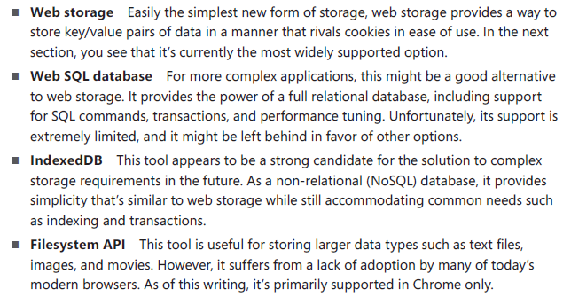

### Considering security

The major thing all four storage options have in common is that the data being stored is tied to the URL (or origin), to ensure that the data can't be accessed by other sites.

Therefore the same host, port, and protocol (http vs https) must be provided before a webpage can access data written by another page.

E.g.

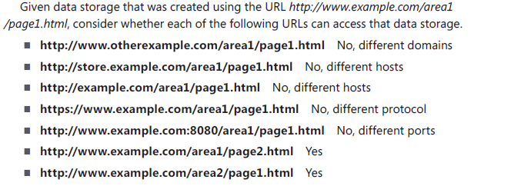

**Security Note**: It would be better practice to avoid using web storage entirely if your site will live within a shared domain in the future, because any sub-site within the domain would be able to access your data.